ORDERING ELEMENTS OF LIST

Ordering elements of list consist of two types,

* Reverse()
* Sort()

1. Reverse()

Reverse() is used to display the elements in the list in the reverse order.

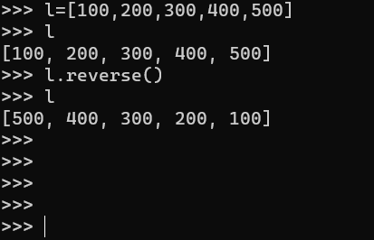

1. Sort()

We can use sort() in the following types

* Numbers
* String

1. For numbers

In this method the default nature of sorting order is ascending.

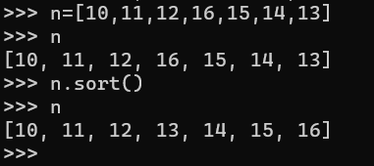

1. For string

In this method the default nature of sorting the order is alphabetical

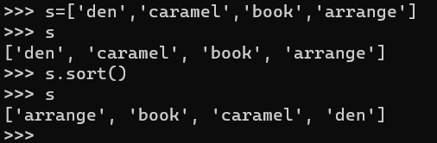

**Note : Python shows error when we use both numbers and string elements for sorting**

